

Course Tittle: Structured Programming Lab

Course Code: SE122

Assignment on:

Programming Problem

Submitted to:

Esraq Humayun

Lecturer, Department of Software Engineering

Submitted by:

Md. Abdul Alim

ID: 221-35-1043

Submission date: 28/06/2022

**Lab Report(Exercises)**

**Structured Programming Lab**

**Deadline: 28/6/2022**

**1. Write a program in C to store elements in an array and print it.**

#include <stdio.h>

int main()

{

int N;

// length

printf("Please input array size : \n");

scanf("%d",&N);

int arr[N];

// input array element

printf("Please input array element : \n");

for (int i = 0; i < N; i++)

{

scanf("%d",&arr[i]);

}

printf("Output array : \n");

for (int i = 0; i < N; i++)

{

printf("%d ",arr[i]);

}

return 0;

}

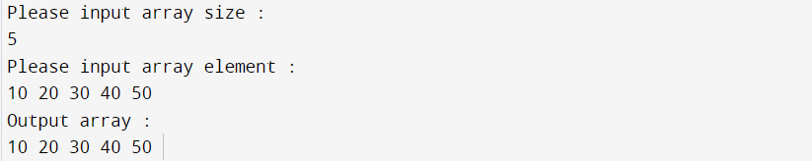

**2. Write a program in C to read n number of values in an array and display it in reverse order.**

#include <stdio.h>

int main()

{

int N;

printf("Please input N number: \n");

scanf("%d",&N);

int count = N;

int arr[N];

printf("Please input element num : \n");

for (int i = 0; i < count; i++)

{

scanf("%d",&arr[i]);

}

for (int i = count-1; i >= 0 ; i--)

{

printf("%d ",arr[i]);

}

return 0;

}

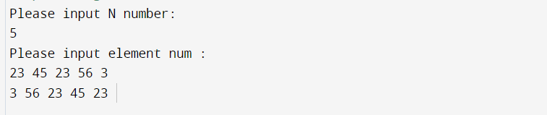

**3. Write a program in C to find the sum of all elements of the array**

#include <stdio.h>

void fun(int arr[],int count){

int sum = 0;

for(int i = 0; i < count ; i++)

{

sum += arr[i];

}

printf("Elements Sum : %d",sum);

}

int main()

{

int N;

printf("Please input N number: \n");

scanf("%d",&N);

int count = N;

int arr[N];

printf("Please input element num array 1: \n");

for (int i = 0; i < count; i++)

{

scanf("%d",&arr[i]);

}

fun(arr, count);

return 0;

}

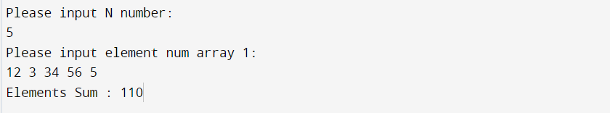

**4. Write a program in C to copy the elements of one array into another array**

#include <stdio.h>

int main()

{

int N;

printf("Please input N number: \n");

scanf("%d",&N);

int count = N;

int arr[N];

int arr2[N];

printf("Please input element num array 1: \n");

for (int i = 0; i < count; i++)

{

scanf("%d",&arr[i]);

arr2[i] = arr[i];

}

printf("arr2 : ");

for (int i = 0; i < count ; i++)

{

printf("%d ",arr2[i]);

}

printf("\n");

return 0;

}

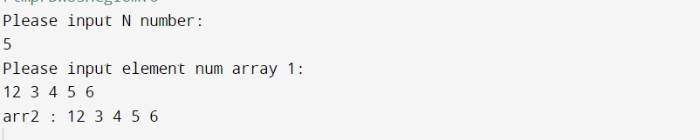

**5. Write a program in C to count a total number of duplicate elements in an array.**

#include <stdio.h>

void main()

{

int arr1[100];

int arr2[100];

int arr3[100];

int n,mm=1,ctr=0;

int i, j;

printf("Input the number of elements to be stored in the array :");

scanf("%d",&n);

printf("Input %d elements in the array :\n",n);

for(i=0;i<n;i++)

{

scanf("%d",&arr1[i]);

}

for(i=0;i<n; i++)

{

arr2[i]=arr1[i];

arr3[i]=0;

}

for(i=0;i<n; i++)

{

for(j=0;j<n;j++)

{

if(arr1[i]==arr2[j])

{

arr3[j]=mm;

mm++;

}

}

mm=1;

}

for(i=0; i<n; i++)

{

if(arr3[i]==2){ctr++;}

}

printf("The total number of duplicate elements found in the array is: %d \n", ctr);

printf("\n");

}

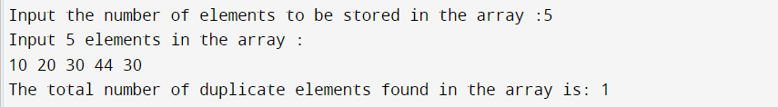

**6. Write a program in C to print all unique elements in an array**

#include <stdio.h>

int main()

{

int N;

printf("Please input N number: \n");

scanf("%d",&N);

int arr[N];

printf("Please input element : \n");

for (int i = 0; i < N; i++)

{

scanf("%d",&arr[i]);

}

int temp;

int len = N;

for (int i = 1; i < len; i++)

{

for (int j = 0; j < len-1; j++)

{

if(arr[j] > arr[j+1]){

temp = arr[j];

arr[j] = arr[j+1];

arr[j+1] = temp;

}

}

}

int i, t, j, k;

for(i=0; i<len; i++)

{

t = 1;

for(j=i+1; j<len; j++)

{

if(arr[i]==arr[j])

{

for(k=j; k<len-1; k++)

{

arr[k] = arr[k+1];

}

len--;

j--;

t = 0;

}

}

if( t == 0)

{

for(j=i; j< len -1; j++)

{

arr[j] = arr[j+1];

}

len--;

i--;

}

}

for (int i = 0; i < len; i++)

{

printf("%d ",arr[i]);

}

return 0;

}

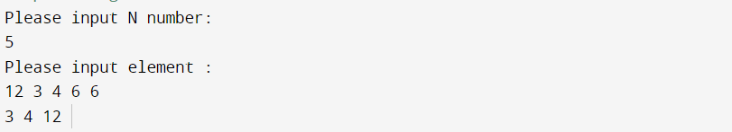

**7. Write a program in C to merge two arrays of same size sorted in descending order**

#include <stdio.h>

int main()

{

int arr[5] = {3,2,1,4,5};

int arr2[5] = {6,9,8,7,10};

int arr3[10];

//merge array

for (int i = 0; i < 5 ; i++)

{

arr3[i] = arr[i];

}

int t = 5;

for (int i = 0; i < 5 ; i++)

{

arr3[t++] = arr2[i];

}

// descending order

int temp ;

for (int i = 0; i < 10 ; i++)

{

for (int j = i+1; j < 10; j++)

{

if(arr3[i] < arr3[j]){

temp = arr3[i];

arr3[i] = arr3[j];

arr3[j] = temp;

}

}

}

// output arr

for (int i = 0; i < 10 ; i++)

{

printf("%d ",arr3[i]);

}

return 0;

}



**8. Write a program in C to find the maximum and minimum element in an array.**

#include <stdio.h>

int main()

{

int N;

printf("Please input N number: \n");

scanf("%d",&N);

int arr[N];

printf("Please input element : \n");

for (int i = 0; i < N; i++)

{

scanf("%d",&arr[i]);

}

// ascending order

int temp ;

for (int i = 0; i < 5 ; i++)

{

for (int j = i+1; j < 5; j++)

{

if(arr[i] > arr[j]){

temp = arr[i];

arr[i] = arr[j];

arr[j] = temp;

}

}

}

// output arr

printf("Minimum Num of Elements : %d\n",arr[0]);

printf("Maximum Num of Elements : %d\n",arr[4]);

return 0;

}

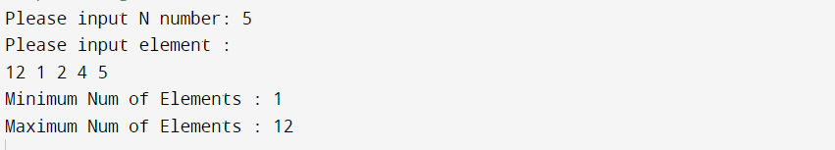

**9. Write a program in C to separate odd and even integers in separate arrays**

#include <stdio.h>

int main()

{

int N;

printf("Please input N number: \n");

scanf("%d",&N);

int arr[N];

printf("Please input element : \n");

for (int i = 0; i < N; i++)

{

scanf("%d",&arr[i]);

}

// ascending order

int temp , t = 0, t2 = 0,odd[5],even[5];

for (int i = 0; i < 5 ; i++)

{

if(arr[i] % 2 == 0){

even[t++] = arr[i];

}

else{

odd[t2++] = arr[i];

}

}

// output arr

for (int i = 0; i < t ; i++)

{

printf("Even Num of Elements : %d \n",even[i]);

}

for (int i = 0; i < t2 ; i++)

{

printf("Odd Num of Elements : %d \n",odd[i]);

}

return 0;

}

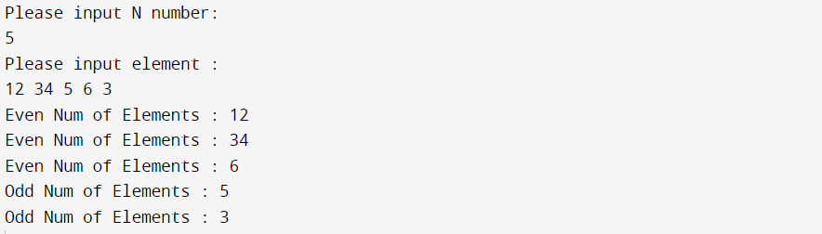

**10. Write a program in C to sort elements of arrays in ascending order.**

#include <stdio.h>

int main()

{

int N;

printf("Please input N number: \n");

scanf("%d",&N);

int arr[N];

printf("Please input element : \n");

for (int i = 0; i < N; i++)

{

scanf("%d",&arr[i]);

}

// ascending order

int temp ;

for (int i = 0; i < N ; i++)

{

for (int j = i+1; j < N; j++)

{

if(arr[i] > arr[j]){

temp = arr[i];

arr[i] = arr[j];

arr[j] = temp;

}

}

}

//ascending order output

printf("Ascending order : ");

for (int i = 0; i < N; i++)

{

printf(" %d",arr[i]);

}

return 0;

}

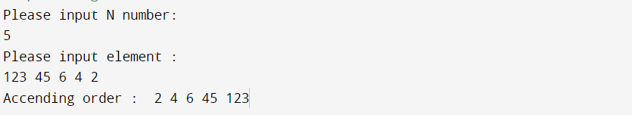

**11. Write a program in C to sort elements of the array in descending order.**

#include <stdio.h>

int main()

{

int N;

printf("Please input N number: \n");

scanf("%d",&N);

int arr[N];

printf("Please input element : \n");

for (int i = 0; i < N; i++)

{

scanf("%d",&arr[i]);

}

// deccending order

int temp ;

for (int i = 0; i < N ; i++)

{

for (int j = i+1; j < N; j++)

{

if(arr[i] < arr[j]){

temp = arr[i];

arr[i] = arr[j];

arr[j] = temp;

}

}

}

//deccending order output

printf("Deccending order : ");

for (int i = 0; i < N; i++)

{

printf(" %d",arr[i]);

}

return 0;

}

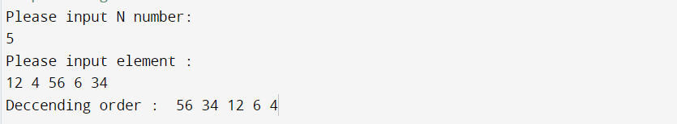

**12. Write a program in C to insert New value in the array (unsorted list ).**

#include <stdio.h>

int main()

{

int arr[] = {32,23,111,44,55};

int len = sizeof(arr)/sizeof(arr[0]);

//Insert elements

printf("Please input insert array element : \n");

scanf("%d",&arr[len]);

// output

for (int i = 0; i < len+1; i++)

{

printf("%d ",arr[i]);

}

return 0;

}

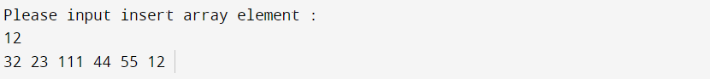

**13. Write a program in C to delete an element at desired position from an array.**

#include <stdio.h>

int main()

{

int n,del_posi,len;

// Length of array

printf("Please input array length : \n");

scanf("%d",&len);

int arr[len];

//input array element

printf("Please input array element : \n");

for (int i = 0; i < len; i++)

{

scanf("%d",&arr[i]);

}

// array delete position

printf("Please input delete element. \n");

scanf("%d",&del_posi);

// Deleting array position

for (int i = del_posi-1; i < len; i++)

{

arr[i] = arr[i+1];

}

len--;

//print new array

for (int i = 0; i < len; i++)

{

printf("%d ",arr[i]);

}

return 0;

}

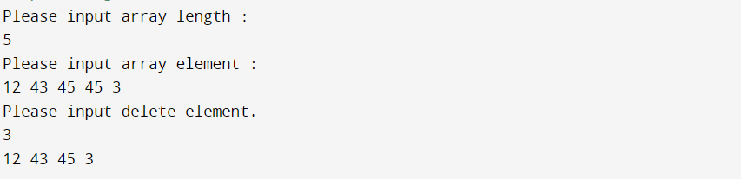

**14. Write a program in C to find the second largest element in an array.**

#include <stdio.h>

int main()

{

int N;

printf("Please input N number: \n");

scanf("%d",&N);

int arr[N];

printf("Please input element : \n");

for (int i = 0; i < N; i++)

{

scanf("%d",&arr[i]);

}

int len = sizeof(arr)/sizeof(arr[0]);

// ascending order

int temp ;

for (int i = 0; i < len ; i++)

{

for (int j = i+1; j < len; j++)

{

if(arr[i] > arr[j]){

temp = arr[i];

arr[i] = arr[j];

arr[j] = temp;

}

}

}

//ascending order output

printf("Second Largest Element : %d",arr[len-2]);

return 0;

}

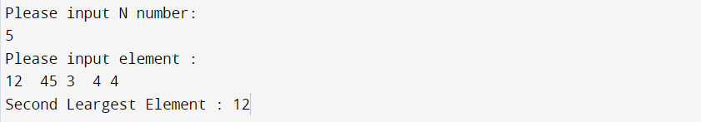

**15. Write a program in C to find the second smallest element in an array**

#include <stdio.h>

int main()

{

int N;

printf("Please input N number: \n");

scanf("%d",&N);

int arr[N];

printf("Please input element : \n");

for (int i = 0; i < N; i++)

{

scanf("%d",&arr[i]);

}

int len = sizeof(arr)/sizeof(arr[0]);

// ascending order

int temp ;

for (int i = 0; i < len ; i++)

{

for (int j = i+1; j < len; j++)

{

if(arr[i] > arr[j]){

temp = arr[i];

arr[i] = arr[j];

arr[j] = temp;

}

}

}

//ascending order output

printf("Second smallest Element : %d",arr[1]);

return 0;

}

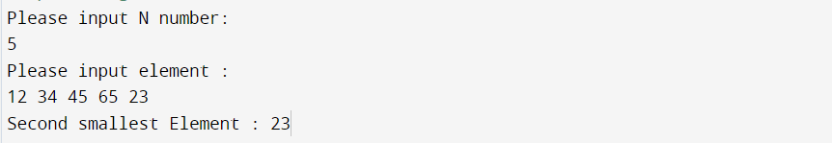

**16. Write a program in C for a 2D array of size 3x3 and print the matrix.**

#include <stdio.h>

int main()

{

int arr[3][3],temp;

// scan matrix

printf("Please input 3x3 Matrix : \n");

for (int i = 0; i < 3 ; i++)

{

for (int j = 0; j < 3; j++)

{

scanf("%d",&arr[i][j]);

}

}

//output

printf("Output : \n");

for (int i = 0; i < 3 ; i++)

{

for (int j = 0; j < 3; j++)

{

printf("%d ",arr[i][j]);

}

printf("\n");

}

return 0;

}

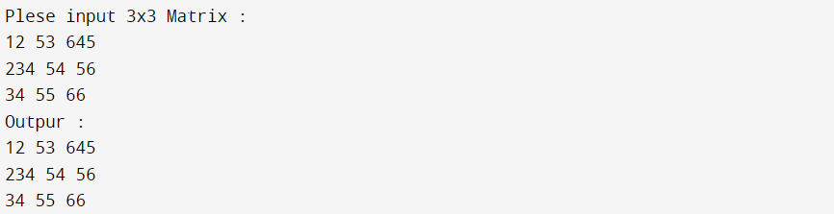

**17. Write a program in C for addition of two Matrices of same size.**

#include <stdio.h>

int main()

{

int arr[3][3];

int arr2[3][3];

int arr3[3][3];

// scan matrix

printf("Please input 3x3 first Matrix : \n");

for (int i = 0; i < 3 ; i++)

{

for (int j = 0; j < 3; j++)

{

scanf("%d",&arr[i][j]);

}

}

printf("Please input 3x3 second Matrix : \n");

for (int i = 0; i < 3 ; i++)

{

for (int j = 0; j < 3; j++)

{

scanf("%d",&arr2[i][j]);

}

}

//additional matrix

for (int i = 0; i < 3 ; i++)

{

for (int j = 0; j < 3; j++)

{

arr3[i][j] = arr[i][j] + arr2[i][j];

}

}

//output

printf("Output : \n\n");

for (int i = 0; i < 3 ; i++)

{

for (int j = 0; j < 3; j++)

{

printf("%d ",arr3[i][j]);

}

printf("\n");

}

return 0;

}

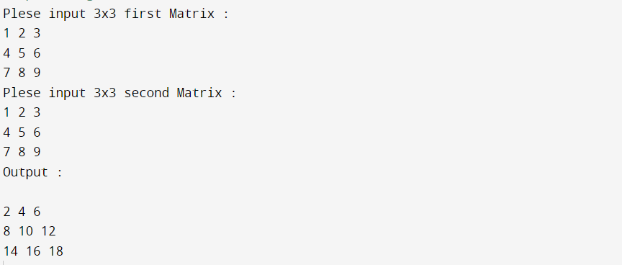

**18. Write a program in C to display the n terms of odd natural numbers and their sum.**

#include <stdio.h>

int main()

{

int N,sum = 0;

printf("Input N number : \n");

scanf("%d",&N);

for (int i = 1; i <= N; i++)

{

if(i%2 == 1){

sum += i;

}

}

//natural number

printf("Natural Odd Numbers : ");

for (int i = 1; i <= N; i++)

{

if(i%2 == 1){

printf("%d ",i);

}

}

printf("\nNatural Odd numbers Sum : %d\n",sum);

return 0;

}

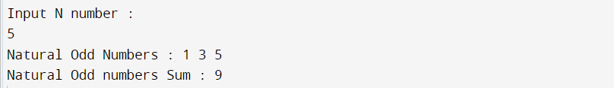

**19. Write a program in C to display the n terms of harmonic series and their sum.**

#include <stdio.h>

int main()

{

int N;

double sum = 0.0 , i;

printf("Input N number : \n");

scanf("%d",&N);

for ( i = 1; i <= N; i++)

{

sum += (1.0/i);

}

//natural number

printf("Harmonic series : 1");

for (int j = 2; j <= N; j++)

{

printf(" + 1/%d",j);

}

printf("\nHarmonic numbers Sum : %.2lf\n",sum);

return 0;

}

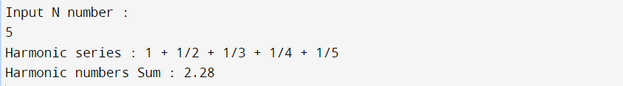

**20. Write a C program to determine whether a given number is prime or not.**

#include <stdio.h>

#include <math.h>

int main()

{

int N,count = 0;

printf("Input N number : \n");

scanf("%d",&N);

if(N == 1 || N == 0){

count = 1;

}

for(int i=2; i <=sqrt(N) ; i++){

if(N%i == 0){

count = 1;

}

}

if(count == 0){

printf("%d is a Prime Number \n",N);

}

else{

printf("%d is a Not Prime Number\n",N);

}

return 0;

}

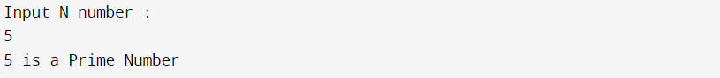

**21. Write a program in C to find the number and sum of all integers between 100 and 200 which are divisible by 9.**

#include <stdio.h>

#include <math.h>

int main()

{

int sum = 0;

for(int i=100 ; i <= 200 ; i++){

if(i%9 == 0){

sum += i;

printf("%d ",i);

}

}

printf("\nSum : %d\n",sum);

return 0;

}



**22. Write a program in C to find the sum of the series 1 +11 + 111 + 1111 + .. n terms**

#include <stdio.h>

int main()

{

int n,mod,series= 0;

long long int result=0;

// print n number of sum

printf("Please print n number of sum in series : \n");

scanf("%d",&n);

//print series

printf("The series : 1");

while (n--)

{

mod = 1;

series = series * 10 + mod;

printf(" %d",series);

result += series;

}

printf("\nThe series sum is : %d\n",result);

return 0;

}

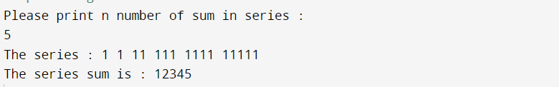

**23.Write the code to find the factorial of that number.**

#include <stdio.h>

int main()

{

int N,fact=1;

printf("Input N number : \n");

scanf("%d",&N);

// ascending order

int temp ;

for (int i = 1; i <= N ; i++)

{

fact *= i;

}

printf("%d factorial is : %d",N,fact);

return 0;

}

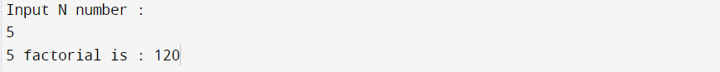

**24.Enter a six digit number and print the number in reverse order and find the sum of those numbers.**

#include <stdio.h>

int main()

{

int N,reverse_num = 0, mod,sum = 0;

printf("Please input six digit number :\n");

scanf("%d",&N);

while ( N != 0){

mod = N%10;

sum += mod;

reverse_num = reverse_num * 10 + mod;

N /= 10;

}

printf("Reverse number : %d\n",reverse_num);

printf("Sum number : %d\n",sum);

return 0;

}

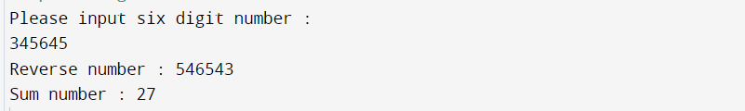

**25.Write a menu driven program which has the following options.**

**I )Factorial**

**ii) Prime or not**

**iii) odd**

**iv) Even**

**v) Exit**

#include <stdio.h>

#include <math.h>

#include <stdbool.h>

void factorial();

void primeNum();

void odd();

void even();

int main()

{

bool t = true;

while(t){

int N;

printf("Please find your result input num 1: Factorial, 2: Prime , 3: Odd , 4: even , 5: exit \n");

scanf("%d",&N);

if(N == 5){

break;

}

switch (N)

{

case 1:

factorial();

break;

case 2:

primeNum();

break;

case 3:

odd();

break;

case 4:

even();

break;

default:

printf("Your num is wrong. please try again right number\n");

break;

}

}

return 0;

}

// Factorial

void factorial(){

int n;

printf("Please find factorial num : \n");

scanf("%d",&n);

long long int fact = n;

while(n--){

fact *= n;

if(n == 1){

break;

}

}

printf("%lld\n",fact);

}

// Prime or not

void primeNum(){

int N;

printf("Please find Prime or not so input num : \n");

scanf("%d",&N);

int count = 0;

if(N == 1 || N == 0){

count = 1;

}

for(int i=2; i<= sqrt(N); i++){

if(N%i == 0){

count++;

break;

}

}

if(count == 0){

printf("%d is a Prime Number.\n",N);

}

else{

printf("%d is Not a Prime Number.\n",N);

}

}

// Odd or not

void odd(){

int N;

printf("Please check Odd num so input num : \n");

scanf("%d",&N);

if(N%2 == 1){

printf("This number is Odd\n");

}

else{

printf("This number is not Odd\n");

}

}

// Even or not

void even(){

int N;

printf("Please check Even num so input num : \n");

scanf("%d",&N);

if(N%2 == 0){

printf("This number is Even\n");

}

else{

printf("This number is not Even\n");

}

}

